**CHAPTER 1: INTRODUCTION**

* 1. **Overview**

The component of Visual Quality is important aspect in aim and shoot game in a gameplay. Virtual Reality (VR) has long been introduced during the early 1950s. Back then, the machines used to display VR was ugly and big, but it was only quite a few years ago that those machines have been upgraded to much prettier and have their size reduced to a rather small amount. There are limitless possibilities to what the technology of VR has in store for us. To experience VR, the user is required to put on a head-mounted display. This device will enable the user to see into a Virtual Environment. VR in the field of entertainment games already have many uses. In this paper, the researcher plans to focus on the important of lighting in aim and shoot game for visual quality in VR game.

Aim and shoot game are a genre of games that uses the weapon. The purpose of the game is to effectively navigate through a 3D environment, target opposing players and avoid obstacles (Vicencio-Moreira, Mandryk, Gutwin, & Bateman, 2014). It takes time to learn, resulting in a wide range of skill levels (Vicencio-Moreira et al., 2014). These kinds of games can usually be found at Steam.

Over past few years, a lot of aim and shoot type of game have been implemented into VR. However, not many people are aware of the important of lighting in aim and shoot game. This is because players do not care about the lighting. Therefore, this study plans to explore the important of lighting in aim and shoot game for visual quality in VR game.

* 1. **Background of Research**
     1. **Virtual Reality**

“Virtual reality stands for the field of computing which has the objective of creating a virtual world, having one immerse into it and giving one the capability of interacting in this world, while using specific devices to simulate an environment and simulate one by feedback in order to make the experience as real as possible”

(Boas, 2013).

"A high-end user interface that involves real-time simulation and interaction through multiple sensorial channels (vision, sound, touch, smell, taste)" (Ran & Wang, 2011).

* + 1. **Application of Virtual Reality in Aim and Shoot Games**

There are many aim and shoot games that have been implemented into virtual reality application.

Holopoint is pure archery madness. Fight your way through waves of responsive targets, samurai and highly dangerous ninjas – all while drawing, nocking, and shooting your arrows as quickly as possible (Alzan, 2016).

QuiVR literally puts the power of the bow and arrow in your hands. Tasked with defending your keep from an ever- advancing enemy, you will find yourself in a thrilling fight for you very survival. QuiVR is a choice for both VR veterans and newcomers alike (Alvios, 2018).

* 1. **Significance of Study**

In this research, it studied on lighting in aim and shoot game and the component of visual quality in virtual reality game. In this paper, the researcher focused on the important of lighting in aim and shoot game for visual quality in virtual reality game. This research is to identify the type of lighting that applied in aim and shoot game. This research will help you to understand that lighting is important aspect in aim and shoot game in a gameplay.

* 1. **Aim and Objective**

The aim of this research is to review the important of lighting in aim and shoot game for visual quality in virtual reality game. The research objectives are:

* To investigate the type of lighting that applied in aim and shoot game.
* To understand the common aim and shoot game that has the important of lighting in virtual reality game.
  1. **Research Question**
* What are the type of lighting that applied in aim and shoot game?
* What are the common aim and shoot game that has the important of lighting in virtual reality games?
  1. **Problem Statement**

The implementation of Virtual Reality technology being taken into all kinds of field; most people are only interested in the field of entertainment games. But, not many people are aware of the important lighting in a game. This is because players want something that would make them immerse.

* 1. **Justification of Research**

Paper that is found about lighting in aim and shoot game, it was shown that there are no researcher who has done in-depth about this study of this aspect. Game developers lack of consideration/knowing about the implementation of lighting in aim and shoot game, making them having trouble to develop amazing game design for players. Hence, this research is carried out to serve as a resource/guideline for all game developers to understand the important of lighting in aim and shoot game. This research is to prove that lighting in virtual reality game is important aspect in aim and shoot game in a gameplay.

* 1. **Scope of Study**

In this research the researcher intends to research on the types of lighting that apply in games and lighting improve virtual reality games. The researcher will study about various kinds of light in aim and shoot game for visual quality in virtual reality game by collecting previous researches and secondary data. To analysing aim and shoot game and identify the game implementation of lighting. Three popular aim and shoot games will be selected and analyse the game implementation of lighting within the game itself. This scope of this research will not cover on any other aspects for data analyse beside the type of lighting in aim and shoot game for visual quality in virtual reality game.

* 1. **Organisation of Dissertation**

Chapter one discusses the Virtual Reality, and the application of Virtual Reality in aim and shoot games. Research aim and objective on this research are also presented. Chapter two will list out and review a visual quality and type of light in 3D. This chapter intends to answer the first proposed research question. Then Chapter three will explain the methods of data collection. An analysis on how different type of lights has different effect in a gameplay. This chapter intends to answer the second proposed research question. Chapter four will analyse the findings from all the different games in lighting. The different type of lights that are use in their games. Finally, Chapter five will attempt to conclude collected secondary data and provide answers for the research questions which have been proposed in previous chapters.

**CHAPTER 2: LITERATURE REVIEW**

**2.1 Introduction**

In this chapter, the researcher intends to investigate the type of lighting and understand that lighting improve virtual reality game. The researcher believes that by studying about it will give a clear picture on how important lighting in virtual reality game and to know and learn. It can be benefit knowledge to the researcher itself and to other people in the future.

This chapter will answer the first research question, what are the type of lighting? The literature review in this chapter will strengthen the researcher opinion on the important of lighting in aim and shoot game for visual quality in virtual reality games.

**2.2 Visual Quality**

Visual quality is defined as the visual attributes of nature landscape, structure and communities. Visual quality of exiting views using three criteria. First, vividness is the memorability of landscape components as they combine in striking and distinctive visual pattern. Second, intactness is the visual integrity of the nature and human landscape and its freedom from encroaching elements. Third, unity is the visual coherence and compositional harmony of the landscape considered as a whole (Tunnel, 2006).

Computer enable the creation of environment that can be perceived. Virtual environment using lighting to communicate information about the composition and content of the scene. However, quality of light simulated in the virtual environment is controlled entirely artificially (Zimmons, 2004).

Visual image are often used to organize and guide our everyday lives. From road signs, visual images tell us where we should and should no be or should and should not go. This is not entirely different than how games has a visual component, which just much as level design can guide player action and can communicate with the player as much as any amount of dialogue.

Video game will visually communicate with a player is through the heads-up display or HUD. A HUD is the visual overly placed on the screen used to convey information unobtrusively to the player. A HUD’s primary job is to communicate to the player exactly what sort of situation they are in (how much ammo they have, how much time they have left, their score, and their remaining health) at any particular moment without disrupting their vision.

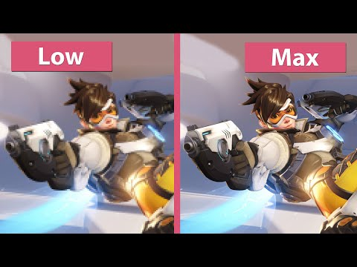

*Figure 2.1 Visual Quality (Source: YouTube, 2015)*

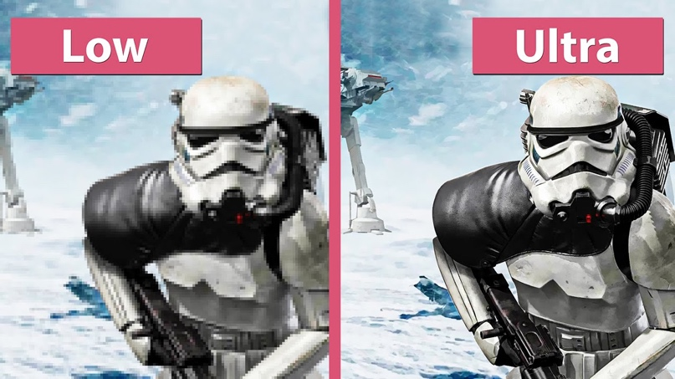

*Figure 2.2 Visual Quality (Source: YouTube, 2015)*

**2.3 Type of light**

There are many type of light than can be use in a virtual environment which are spot light, directional light, point light, ambience light,

**2.3.1 Spot light**

“ Spot light has a specified location and range over which the light falls off. However, the spot light is constrained to an angle, resulting a cone-shaped region of illumination. The centre of the cone points in the forward (Z) direction of the light object. Light also diminishes at the edges of the spot light’s cone. Widening the angle increases the width of the cone and with it increases the size of this fade, known as the penumbra ” (Unity Technologies, 2018).

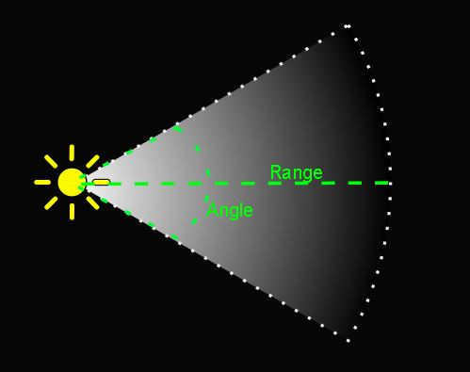

*Figure 2.3 Spot Light (Source: Unity Technologies, 2018)*

“ Spot lights are generally used for artificial light sources such as flashlights, car headlights and searchlights. With the direction controlled from a script, a moving spot light will illuminate just a small area of the scene and create dramatic lighting effects ” (Unity Technologies, 2018).

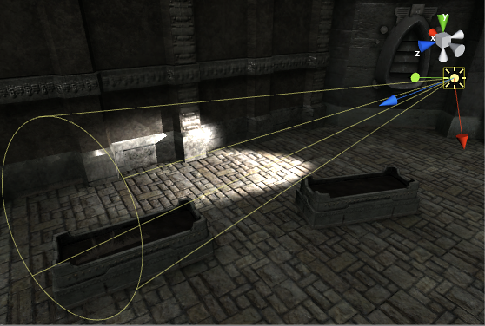

*Figure 2.4 Spot Light (Source: Unity Technologies, 2018)*

**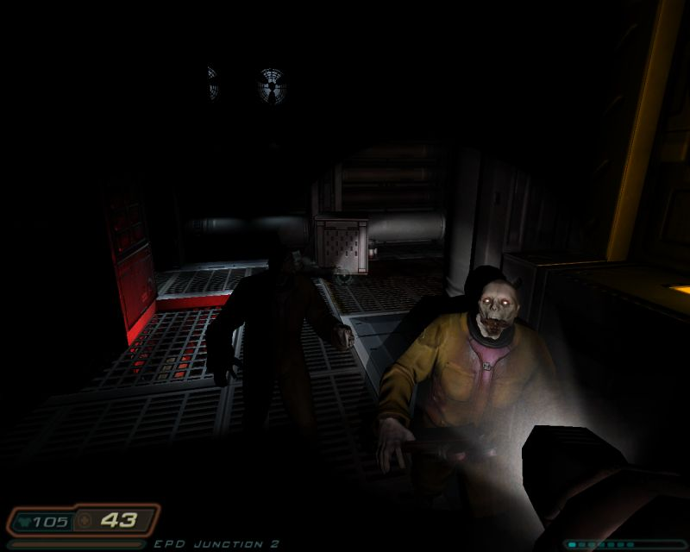**

*Figure 2.5 Spot Light (Source: WordPress, 2014)*

**2.3.2 Directional light**

“ Directional lights are very useful for creating effects such as sunlight in your scene. Behaving in many ways like the sun, directional lights can be thought of as distant light sources which exist infinitely far away. A directional light does not have any identifiable source position and so the light object can be placed anywhere in the scene. All objects in the scene are illuminated as if the light is always from the same direction. The distance of the light from the target object is not defined and so the light does not diminish ” (Unity Technologies, 2018).

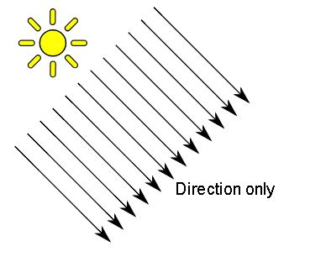

*Figure 2.6 Directional Light (Source: Unity Technologies, 2018)*

“ Directional lights represent large, distant sources that come from a position outside the range of the game world. In a realistic scene, they can be used to simulate the sun or moon. In an abstract game world, they can be a useful way to add convincing shading to objects without exactly specifying where the light is coming from “ (Unity Technologies, 2018).

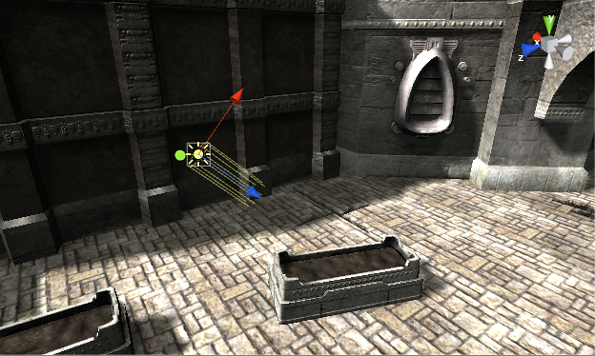

*Figure 2.7 Directional Light (Source: Unity Technologies, 2018)*

**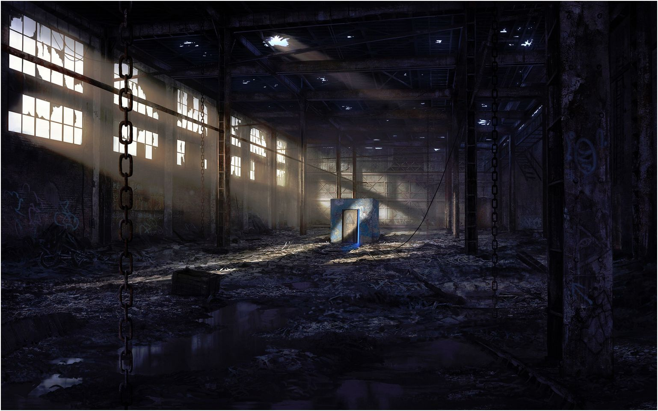**

*Figure 2.8 Directional Light (Source: LOTM Wiki)*

**2.3.3 Point light**

“A point lights is located at a point in space and sends light out in all directions equally. The direction of light hitting a surface is the line from the point of contact back to the centre of the light object. The intensity diminishes with distance from the light, reaching zero at a specified range. Light intensity is inversely proportional to the square of the distance from the source. This is known as ‘inverse square law’ and is similar to how light behaves in the real world” (Unity Technologies, 2018).

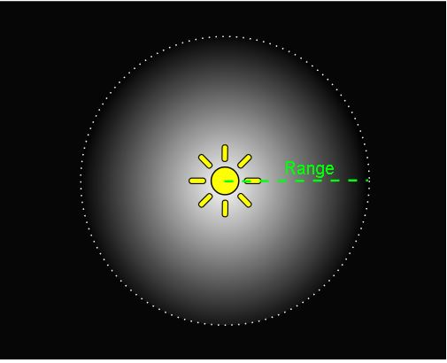

*Figure 2.9 Point Light (Source: Unity Technologies, 2018)*

“Point lights are useful for simulating lamps and other local sources of light in a scene. You can also use them to make a spark or explosion illuminate its surroundings in a convincing way ” (Unity Technologies, 2018).

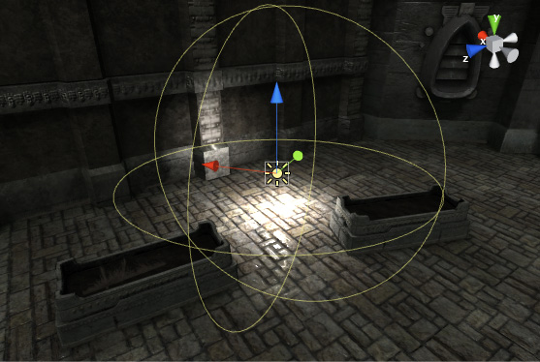

*Figure 2.10 Point Light (Source: Unity Technologies, 2018)*

**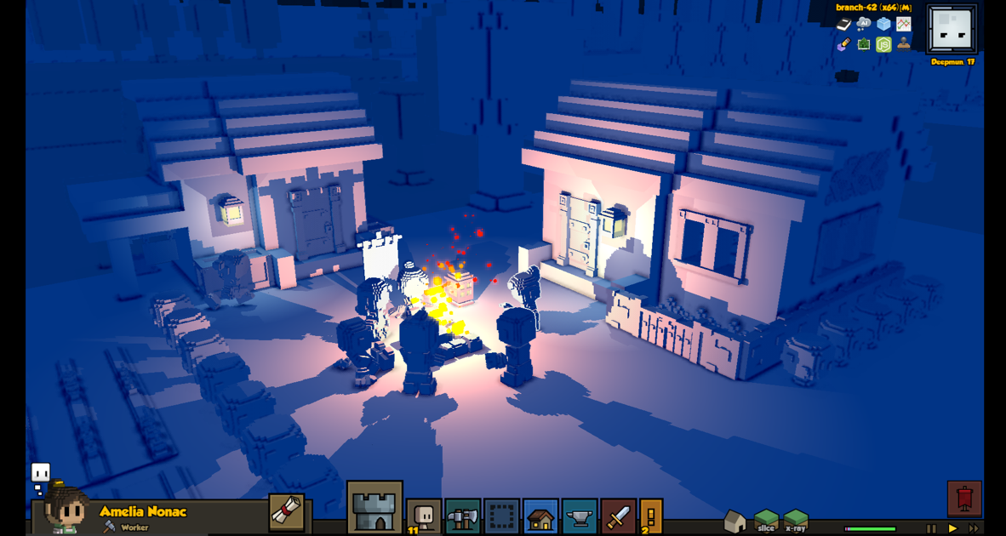**

*Figure 2.11 Point Light (Source: Stone hearth, 2017)*

**2.3.4 Ambient light**

“Ambient light is light that is present all around the scene and doesn’t come from any specific source object. It can be an important contributor to the overall look and brightness of a scene. Ambient light can be useful in a number of cases, depending upon your chosen art style. An example would be bright, cartoon style rendering where dark shadows may be undesirable or where lighting is perhaps hand-painted into textures. It also can be useful if you need to increase the overall brightness of the scene without adjusting individual lights” (Unity Technologies, 2018).

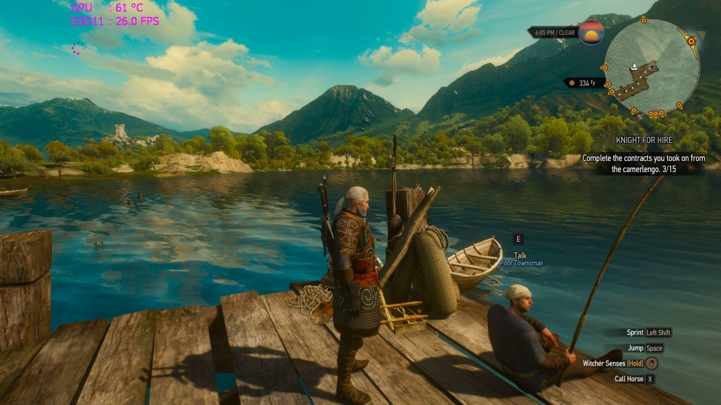

*Figure 2.12 Ambient Light (Source: YouTube, 2016)*

**2.4 Things Every Great Aim and Shoot game need**

**2.4.1 Guns that move us**

“If enemies push us around the map through threat of damage, then our gun is what pulls us to them. A shooter's guns should look cool in our hands, should sound amazing, and should help us engage with the game space. Video games are limited in their ability to create haptic feedback. A lot of attention has to be paid to the way the gun acts in order to make it feel as if you are holding it without actually doing so. The best shooter weaponry helps us move around a combat space. Halo's ineffective-at-range MA5B helps pull players close to Elites, encouraging a duel of punches. Sniper rifles encourage us to seek high vantage points. Shotguns are all about close quarters combat.”

(Buford, 2014).

**2.4.2 Interesting Movement**

“Movement has been prioritized in the genre from the very beginning. It's more interesting when your movement through the game world is part of the fun. [or, perhaps] It's more interesting when your virtual legs have something exciting to do, too. It's one thing to be able to climb a ladder. It's another thing to jump, then activate a jetpack, and jump a bit higher, maintaining forward momentum while gaining height. Likewise, being able to quickly sidestep enemy fire, slide under a barrier to reach a hard-to-access spot, and wall-run all make for a more engaging game. Interesting movement features aren't enough. Being able to move around also requires, well, places that are actually fun to move around in”

(Buford, 2014).

**2.4.3 Maps that make you think**

“Before we get a gun, we're given a perspective to use and a space to walk around in. You need level design that empowers and entices you to move. Engagement is the texture and weight of a game, the thing that draws you into the experience. Instead of just mashing the X button to attack your foes, you have to think about engaging them. it's all about keeping you thinking about the combat and giving you quality time with your enemies”

(Buford, 2014).

**2.4.4 Worthy Opponents**

“A good shooter enemy's job is to move the player around the map. Enemies should be tough but also work to make you utilize the movement mechanics and the map you're in—in other words, enemies are about pushing you to use all the elements of the game. They're not fodder to be pointed and clicked on. They're environmental hazards to move you through the space in interesting ways. Good enemies encourage movement, pushing players around the map”

(Buford, 2014).

**Table 2.5**

|  |
| --- |
| **Type of Light** |
| Spot Light  Directional Light  Point Light  Ambient Light |
| **Aim and Shoot** |
| Guns that move us  Interesting Movement  Map That Make You Think  Worthy Opponents |
| **Visual Quality** |
| HUD  High quality  Low quality |

**2.6 Chapter Summary**

This chapter has answer research question one which is what are the lighting that applied in aim and shoot game. The Table 2.5 shown above summarises the literature review of the type of lighting in aim and shoot game for visual quality. The listed in Table 2.5 are the element of lighting, aim-shoot game and visual quality. These element will be used for in the analysis section of the dissertation in Chapter 4 along with top 3 aim and shoot games.

**CHAPTER 3: METHODOLOGY**

**3.1 Introduction**

In this chapter, researcher will introduce and provide the detailed information about the methodology and methods used to collect the data in this research. The research design is case study type which researcher will select few cases and determine data gathering and analysis techniques through the cases. Data, information and facts are used in secondary types. Approaches of analysis are qualitative type.

**3.2 Research Design**

OVERVIEW

CONCLUSION

RESEARCH PROBLEM

GAME ANALYSIS

OBSERVATION

*Figure 3.1 Research Process*

Figure 3.1 is a figure of research process of this research. This research will include a game analysis whereby the researcher will study three type of lighting from top 3 games for aim and shoot games.

For this research, the qualitative method will be based on these questions that are provided in Chapter one:

* What are the type of lighting that applied in aim and shoot game?
* What are the common aim and shoot game that has the important of lighting in virtual reality games?

The secondary research approach would consist of reviewing on existing literature article, data analysis or journal article to extend knowledge toward related topic by other researcher. Secondary data approach is efficient and time saving as the time research process is limited for this research. To understand lighting helps in improving virtual reality game, the researcher uses keywords such as lighting, aim and shoot, visual quality and virtual reality game to find relevant articles in the domain.

The top 3 aim and shoot games will be selected to conduct the game analysis. The selected aim and shoot games which are (A) Doom, (B) Insurgency, (C) Wolfenstein: The New Order. These three aim and shoot games were chosen based on few criteria:-

1. Selected aim and shoot games must have lighting in their gameplay.
2. The aim and shoot games must obtain 90% and above of good rating in Steam 2018.
3. B. C.

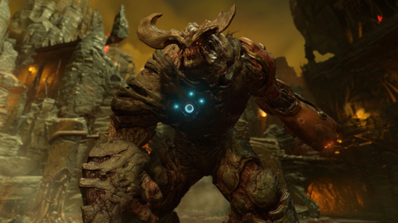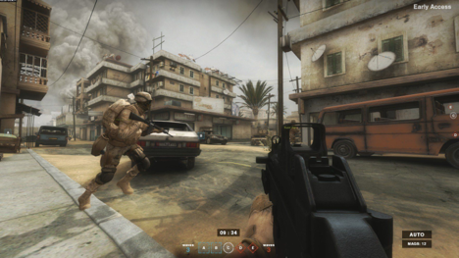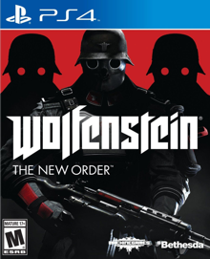

**3.3 Reliability & validity**

**3.3.1 Secondary Data Analysis**

The researcher uses secondary data analysis for the research problem which stated in Chapter one. The researcher source of data included reliable search engine browsers such Google Scholar, Google, Mendeley and vlib. In order to gain valid data, the researcher would prefer to search for more literature review from online journal, article and scholar journal to gain more supportive evidence of the obtained more data.

**3.4 Research approach & methodology**

**3.4.1 Data Collection Method**

The researcher chooses one method as main data collection techniques which is secondary data collection in order to collect sufficient and interrelated data to solve the research objectives of this study. Nevertheless, the researcher used qualitative research method.

**3.5 Chapter Summary**

This chapter has covered the method of research for the study. By studying the data that have been collected and analysed, this research is a qualitative research approach in the same row with the following plan, a literature review and research information and images from the internet associated with certain aim and shoot game is conducted. Moreover, research is an overview of relevant and important literature to create a context and background for the research. This will help to establish the information on the aim and scope of study.

**CHAPTER 4: DATA ANALYSIS**

**4.1 Introduction**

This chapter answered the research question as stated on chapter one through findings and gathered using secondary data approach. Research question number one is type of lighting. The researcher determines this question by using secondary data analysis involving various articles and journal to draw the conclusion. To answer the research question number two, the researcher conduct secondary research to collect and analyse the data of top 3 aim and shoot games selected are Doom, Insurgency, and Wolfenstein: The New Order.

**4.2 Aim and Shoot Games Analysis**

**4.2.1 Doom**

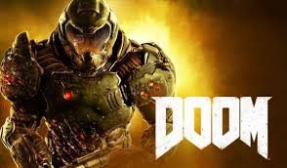

*Figure 4.1 Doom (Source: G2A)*

Doom is a soft reboot of the Doom franchise produced by id Software and published by Bethesda Softworks. The researcher will analyse on Doom game which will be shown in Table 4.1 below.

**Table 4.1 Characteristic Analysis of Doom Game**

|  |  |
| --- | --- |
| Characteristic | Analysis of Doom game |
| Type of lights   * Spot Light * Directional Light * Point Light * Ambient Light | The Doom have outside environment and the type light been use is ambient light which can be seen in figure 4.3. Ambient light mostly been used when it is at outside. The game also have indoor which mostly use point light because there is no sunlight which can be seen in figure 4.4.  doomEnvironment2  *Figure 4.2 Doom (Source: YouTube, 2016)*  ../../Users/Hanizah/Desktop/Screenshot%202018-12-13%20at%208.5  *Figure 4.3 Doom (Source: YouTube, 2016)* |
| Type of Aim-shoot   * Guns that move us * Interesting Movement * Map That Make You Think * Worthy Opponents | The Doom allowed player to shoot the enemies but the gun does not move when fires. It has an interesting movement in the gameplay. The player can jump high around the space while shoot at the enemies which can be seen in figure 4.3. The map in this game is straight forward. The enemy’s movement is pushing you to jump around the space which also can be seen in figure 4.3.  doomEnvironment  *Figure 4.4Doom (Source: WordPress, 2015)*  ../../Users/Hanizah/Desktop/Screenshot%202018-12-13%20at%208.3../../Users/Hanizah/Desktop/Screenshot%202018-12-13%20at%208.4  *Figure 4.5 Doom (Source: YouTube, 2016)* |
| Visual Quality   * HUD * High quality * Low quality | The Doom game have the HUD which can be seen in Figure 4.6. This allowed player to see their own health, weapon selected and weapon ammo. When the player get hit by the enemies it splash on the screen which can also be seen in figure 4.6. The quality of the game is high quality.  doomEnvironment2../../Users/Hanizah/Desktop/Screenshot%202018-12-13%20at%208.0  *Figure 4.6 Doom (Source: YouTube, 2016)* |

**4.2.2 Insurgency**

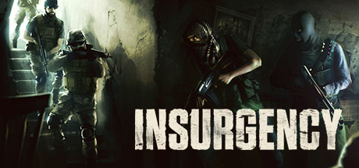

**Figure 4.7 Insurgency**

Insurgency is a multiplayer tactical first-person shooter game developed and published by New World Interactive. It is a standalone sequel to Insurgency. Analysis on Insurgency is conducted by the researcher which will be shown in Table 4.2 below.

**Table 4.2 Charcteristic Analysis on Insurgency Game**

|  |  |
| --- | --- |
| Characteristic | Analysis of Insurgency |
| Type of lights   * Spot Light * Directional Light * Point Light * Ambient Light | The Insurgency have outside and inside environment. The outside environment the insurgency game have two type of light has been use which are ambient light and directional light which can be seen in figure 4.8. The inside environment the insurgency game have also two type of light has been use which are spot light and point light which can be seen in figure 4.9.  ../../Users/Hanizah/Desktop/Screenshot%202018-12-13%20at%2010.3../../Users/Hanizah/Desktop/Screenshot%202018-12-13%20at%2010.3  *Figure 4.8 Insurgency (Source: johnmichaelcreation, 2017)*  district-1../../Users/Hanizah/Desktop/Screenshot%202018-12-13%20at%2010.3  *Figure 4.9 Insurgency (Source: johnmichaelcreation, 2017)* |
| Type of Aim-shoot   * Guns that move us * Interesting Movement * Map That Make You Think * Worthy Opponents | ../../Users/Hanizah/Desktop/Screenshot%202018-12-13%20at%206.5  *Figure 4.10 Insurgency (Source: altchar, 2018)*  The Insurgency allowed player to shoot the enemies the gun does move when fires. It can also move side to side which can be seen in figure 4.10. It has an interesting movement in the gameplay. The player can jump, crouch and run around the space which can be seen in figure 4.11. The map in this game is not straight forward. The player need to think before act which can be seen in figure 4.12. The enemy’s movement is straight forward.  ../../Users/Hanizah/Desktop/Screenshot%202018-12-13%20at%2010.5  *Figure 4.11 Insurgency (Source: YouTube, 2016)*  ../../Users/Hanizah/Desktop/tea  *Figure 4.12 Insurgency (Source: YouTube, 2016)* |
| Visual Quality   * HUD * High quality * Low quality | The Insurgency game do not have HUD. The quality of the game is high quality. |

**4.2.3 Wolfenstein: The New Order**



*Figure 4.13 The New Order (Source: Slant, 2018)*

Wolfenstein: The New Order is an action-adventure first-person shooter game developed by MachineGames and published by Bethesda Softworks. The researcher will analyse on Wolfenstein: The New Order which will be shown in Table 4.3 below.

**Table 4.3 Characteristic Analysis on Wolfenstein: The New Order Game**

|  |  |
| --- | --- |
| Characteristic | Analysis of Wolfenstein: The New Order |
| Type of lights   * Spot Light * Directional Light * Point Light * Ambient Light | The Wolfenstein: The New Order game have outside and inside environment. The outside environment the insurgency game have two type of light has been use which are ambient light and directional light which can be seen in figure 4.14. The inside environment the insurgency game have also two type of light has been use which are spot light and point light which can be seen in figure 4.15.  ../../Users/Hanizah/Desktop/row_germania_city_clos../../Users/Hanizah/Desktop/spotlgih  *Figure 4.14 Wolfenstein: The New Order (Source:The grey backpack)*  ../../Users/Hanizah/Desktop/pointLigh../../Users/Hanizah/Desktop/spotlgih  *Figure 4.15 Wolfenstein: The New Order (Source: the infinite zenith & wordpress,2015 & 2014)* |
| Type of Aim-shoot   * Guns that move us * Interesting Movement * Map That Make You Think * Worthy Opponents | ../../Users/Hanizah/Desktop/Screenshot%202018-12-13%20at%2011.2  *Figure 4.16 Wolfenstein: The New Order (Source: altchar, 2018)*  The Wolfenstein: The New Order game allowed player to shoot the enemies the gun does move when fires which can be seen in figure 4.16. It has an interesting movement in the gameplay. The player can jump, crouch, run, climb, and slide around the space which can be seen in figure 4.17. The map in this game is not straight forward. The player need to think before act which can be seen in figure 4.11. The enemy’s movement is straight forward.  ../../Users/Hanizah/Desktop/Screenshot%202018-12-13%20at%2011.2../../Users/Hanizah/Desktop/Screenshot%202018-12-13%20at%2011.2  *Figure 4.17 Wolfenstein: The New Order (Source: YouTube, 2014)* |
| Visual Quality   * HUD * High quality * Low quality | The *Wolfenstein: The New Order* game do have HUD which can be seen in figure 4.18. The quality of the game is high quality.  ../../Users/Hanizah/Desktop/Screenshot%202018-12-13%20at%2011.2  *Figure 4.18 Wolfenstein: The New Order (Source: YouTube, 2014)* |

**4.3 Discussion**

The Table 4.4 shown below summaries the data analysis of the selected three aim and shoot games. The first Characteristic is type of lights. First, “Spot Light” is found in 2 of the aim and shoot games which is Insurgency and Wolfenstein: The New Order. The Doom game do not have spot light in their game. Second, “Directional Light” is also found 2 of the aim and shoot games which is Insurgency and Wolfenstein: The New Order. The Dome game also do not have directional light in their game. Third, “Point Light” is found in 3 of the aim and shoot games. This show that point light is important element in the game. Lastly, “Ambient Light” is also found in 3 of the aim and shoot games. This also show that ambient light is important element in the game without it the scene of the game is dark.

The following characteristic is type of aim and shoot. First, “Gun That Move Us” is found on Insurgency and Wolfenstein: The New Order games but not in Doom game.

Second, “Interesting Movement” is found in 3 of the aim and shoot games. This show that interesting movement is important to have to the player. Third, “Map That Make You Think” is found in only 1 game which is Insurgency. Lastly, “Worthy Opponents” is also found 1 game which is Doom.

Visual Quality for high quality can be found in 3 of the aim and shoot games and no low quality is found. For the HUD is found in Doom game and Wolfenstein: The New Order game.

**4.4 Table The top 3 aim and shoot game according to type of lights.**

|  |  |  |  |
| --- | --- | --- | --- |
| **Type of light** | Doom | Insurgency | Wolfenstein: The New Order |
| Spot Light |  | ✓ | ✓ |
| Directional Light |  | ✓ | ✓ |
| Point Light | ✓ | ✓ | ✓ |
| Ambient Light | ✓ | ✓ | ✓ |
| **Aim and shoot** |  |  |  |
| Guns that move us |  | ✓ | ✓ |
| Interesting Movement | ✓ | ✓ | ✓ |
| Map That Make You Think |  | ✓ |  |
| Worthy Opponents | ✓ |  |  |
| **Visual Quality** |  |  |  |
| High | ✓ | ✓ | ✓ |
| Low |  |  |  |
| HUD | ✓ |  | ✓ |

**4.4 Chapter Summary**

In this chapter, the researcher covers the second research question which is what are the common aim and shoot game that has the important of lighting in virtual reality game by analysing the three selected aim and shoot games. All of the findings and analysis are tabulated in Table 4.4.

**CHAPTER 5: DISCUSSION AND CONCLUTION**

**5.1 Introduction**

This chapter is to wrap up the findings from this research paper. The purpose of this chapter is to conclude the answers of the research questions. In Chapter 4, the researcher has attempted to answer research question one and two, which are:

* What are the type of lighting that applied in aim and shoot game?
* What are the common aim and shoot game that has the important of lighting in virtual reality games?

From there, the researcher has successfully achieved the research aim and objective of this research.

**5.2 Discussion**

The potentials of aim and shoot games have yet to be unleashed for Virtual Reality (VR) game as there is not much of VR game on aim and shoot developed compared to PC games. It may be more difficult for potential VR game far aim and shoot game developers to do in-depth research in this area. Therefore, this research has offered a bit information and data about what type of lighting applied in aim and shoot game. The researcher analysed, compared, and discussed about the data in this research about what type of lighting has been found in aim and shoot game. Moreover, the researcher has also done in-depth research about thing every great aim and shoot game needs. This research can benefits game developers to develop a much like aim and shoot game for PC game to VR game. At the end of this research, the aim which was to identify the important of lighting in aim and shoot game for visual quality in virtual reality game has been fulfilled. The first research question was to identity the type of lighting that applied in aim and shoot game. A quantitative method was used to answer this research question and it was shown clearly in Table 2.5, Chapter 2. Next, the second research question was to identify the common aim and shoot game that has the important of lighting in virtual reality games. An analysis was conducted by the research and the data gathered was tabulated in Table 4.4, Chapter 4. In conclusion, the aim and research questions of thi research has been overall achieved and answerd.

**5.3 Research Limitations**

Although the study has reached its research objectives, there were few inevitable limitations. First of all, there is time limit for this research which is around fourteen weeks for this study. Therefore, the researcher could not detailed study and analyse for more advantages on lighting which the researcher should have collected more. Secondly, the researcher found that there were limitations of secondary data and findings as there are not many researchers who are doing the topic chosen. Finally, as the researcher had been doing qualitative research and gathering case studies, the study my have biased views that probably influenced the findings. This is one of the limitations of self-reported data.

**5.4 Recommendations for Future Studies**

This research may benefit further researcher who aim to look at similar areas and focus other specifications. There are a few recommendations derived from this study that other researcher can take into considerations.